Reference: https://blueteamlabs.online/home/challenge/log-analysis-sysmon-fabcb83517
Download the Sysmon Logs from the above link
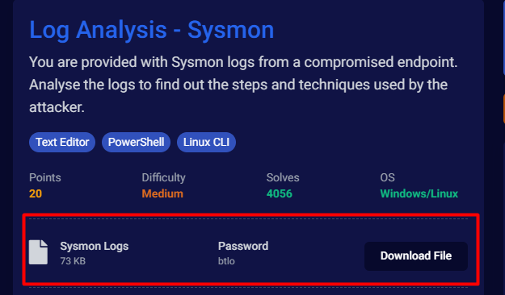

In Linux CLI
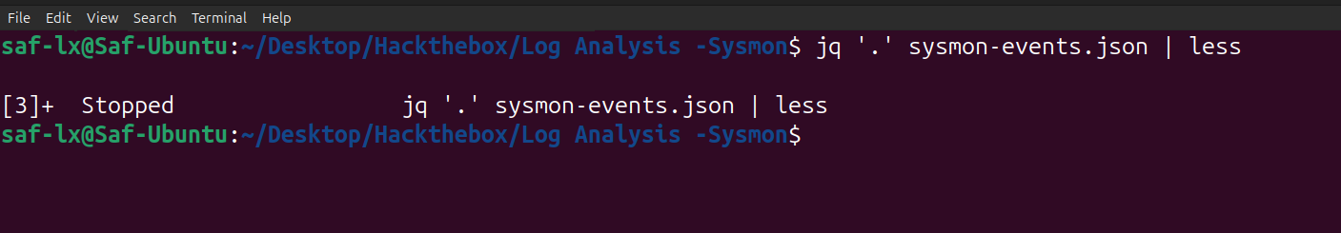
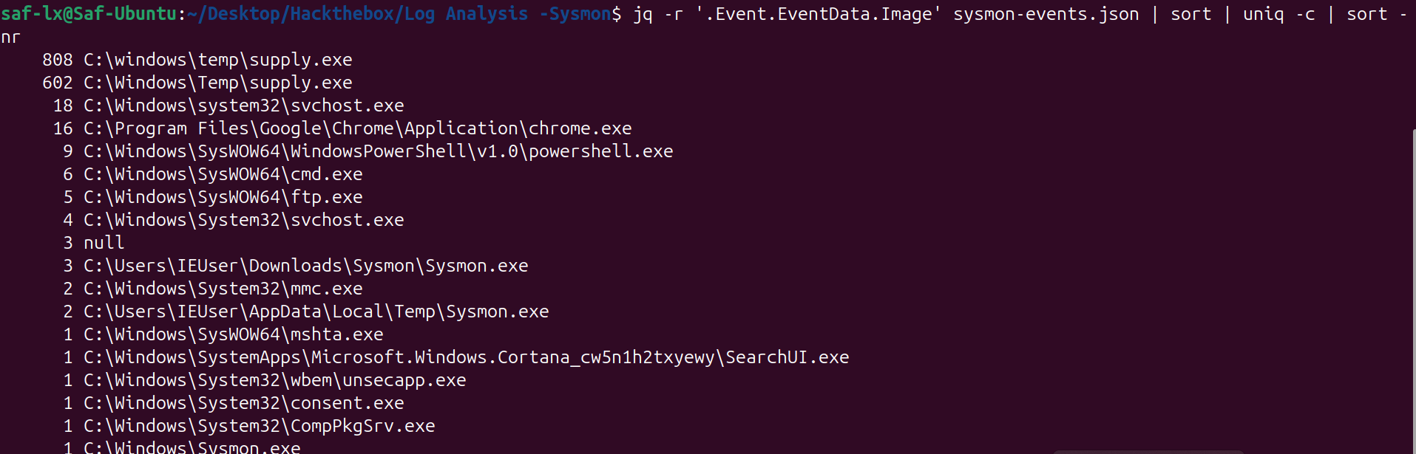
So, number of occurrences of supply.exe is more, we can investigate on it.
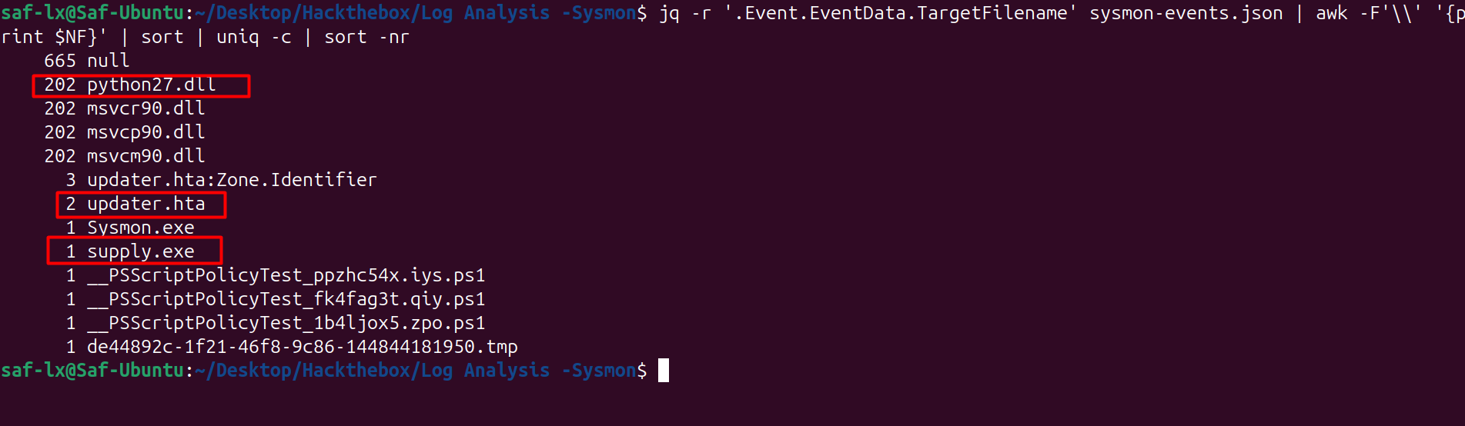
Analyze the DLL file.

Splunk Analysis
